**Base de Datos**

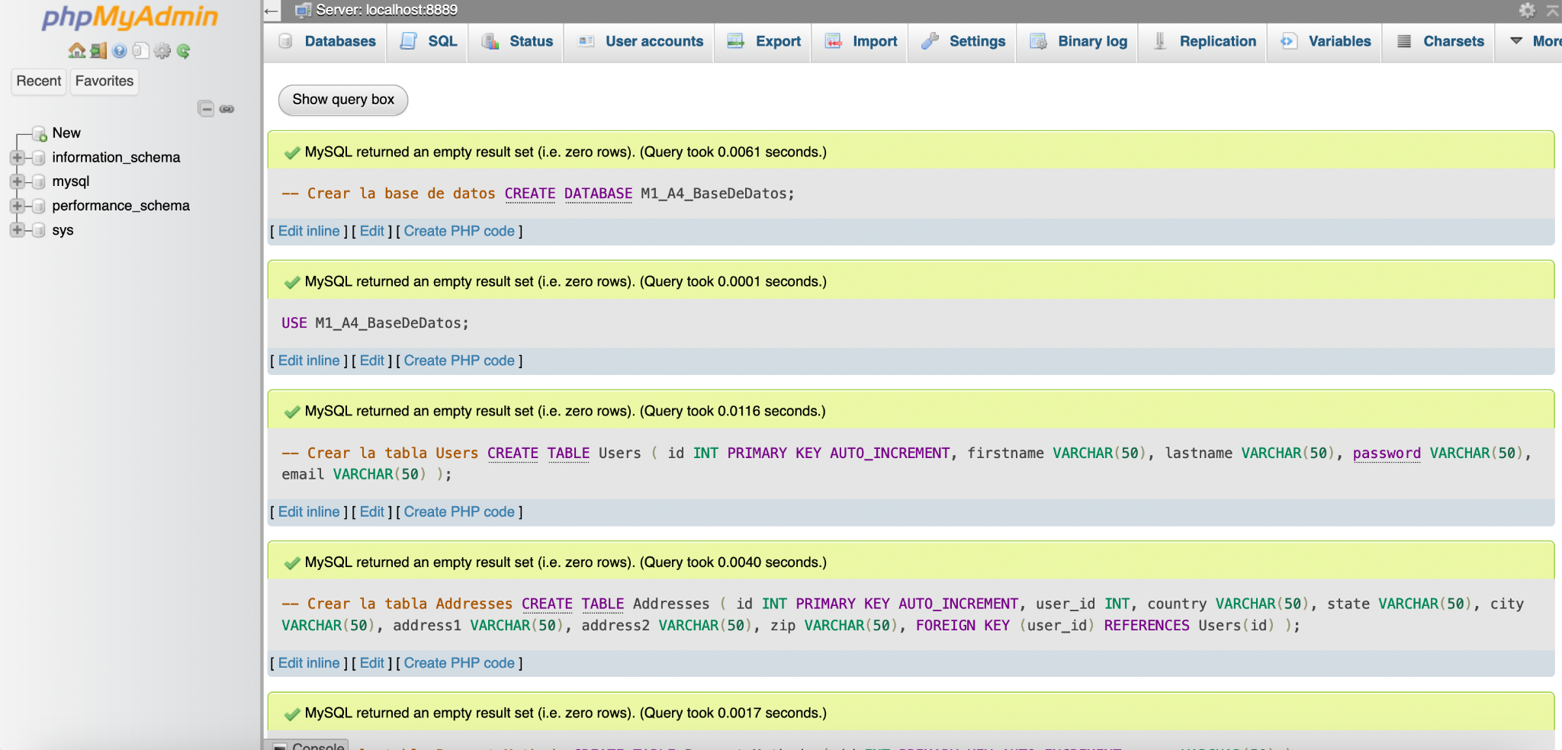

-- Crear la base de datos

CREATE DATABASE M1_A4_BaseDeDatos;

USE M1_A4_BaseDeDatos;

-- Crear la tabla Users

CREATE TABLE Users (

id INT PRIMARY KEY AUTO_INCREMENT,

firstname VARCHAR(50),

lastname VARCHAR(50),

password VARCHAR(50),

email VARCHAR(50)

);

-- Crear la tabla Addresses

CREATE TABLE Addresses (

id INT PRIMARY KEY AUTO_INCREMENT,

user_id INT,

country VARCHAR(50),

state VARCHAR(50),

city VARCHAR(50),

address1 VARCHAR(50),

address2 VARCHAR(50),

zip VARCHAR(50),

FOREIGN KEY (user_id) REFERENCES Users(id)

);

-- Crear la tabla Payment_Methods

CREATE TABLE Payment_Methods (

id INT PRIMARY KEY AUTO_INCREMENT,

name VARCHAR(50)

);

-- Crear la tabla Orders

CREATE TABLE Orders (

id INT PRIMARY KEY AUTO_INCREMENT,

user_id INT,

timestamp DATETIME,

payment_method_id INT,

FOREIGN KEY (user_id) REFERENCES Users(id),

FOREIGN KEY (payment_method_id) REFERENCES Payment_Methods(id)

);

-- Crear la tabla Products

CREATE TABLE Products (

id INT PRIMARY KEY AUTO_INCREMENT,

name VARCHAR(100),

description TEXT,

price DECIMAL(10, 2),

stock INT,

category_id INT

);

-- Crear la tabla Product_Details

CREATE TABLE Product_Details (

order_id INT,

product_id INT,

count INT,

FOREIGN KEY (order_id) REFERENCES Orders(id),

FOREIGN KEY (product_id) REFERENCES Products(id),

PRIMARY KEY (order_id, product_id)

);

-- Crear la tabla Categories

CREATE TABLE Categories (

id INT PRIMARY KEY AUTO_INCREMENT,

name VARCHAR(50)

);

-- Agregar la clave foránea a la tabla Products para la relación con Categories

ALTER TABLE Products

ADD FOREIGN KEY (category_id) REFERENCES Categories(id);